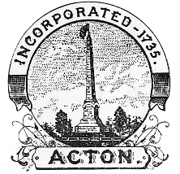
ACTON HISTORICAL COMMISSION
NOTICE OF SITE WALK MEETING

Thursday, May 8th, 2025
8:30
Site Walk

The Acton Historical Commission will conduct a Site Walk
to view the property at 457 Massachusetts Avenue for Proposed Demolition

For more information about the Acton Historical Commission contact
HC@actonma.gov
or 978-929-6631

