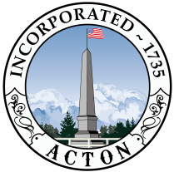
CEMETERY COMMISSION AGENDA
January 8, 2025
2:00pm
Zoom Webinar
Click the link below to join by computer:
https://actonma.zoom.us/j/83079440505
Or join by telephone: 646-876-9923
Meeting ID: 830 7944 0505

- Regular Business
- Review of meeting minutes from 11/13/24.

- New/Special Business
- Public concerns
- Woodlawn Chapel Grant Update
- Request to use $50,000 in trust funds to offset FY26 Cemetery operations
- Conservation Commission 11/20/24 meeting report
- Woodlawn Iron Gates CPA signage
- Cemetery Master Plan
- Capital Improvement Plan
- Review condition of Robbins stone at Capt. Robbins House site
- Progress report on lichen removal from Woodlawn Revolutionary monuments
- Agency fee costs update
- Annual Town Report

- Additional Regular Business
- Next month’s agenda – Feb 12, 2025

The listed agenda items are those reasonably anticipated by the Chair. Not all items may in fact be discussed and other items not listed may also be brought up for discussion to the extent permitted by law.

